


Yenepoya Institute of Arts Science Commerce and Management

High Level Design (HLD)
Anomaly detection For Healthcare Transaction

Student Name: Safnas A
23BSAMD029
LH08

BSc. Artificial Intelligence,
Machine learning and Data Science(IBM,TCS)

Industry Mentor: Mr. Sumit Kumar Shukla
Guided by: Ankitha Poojary Ma’am
Table of Contents
Table of Contents

- Introduction
- Detailed Module Design
- Algorithm Design
- Data Structures
- Function-Level Design
- Error Handling
- Interface Design
- Performance Considerations
- References

- Introduction
Healthcare institutions process thousands of transactions such as insurance claims, treatment charges, billing records, and reimbursements. Due to the high volume of data, it becomes difficult to manually detect fraudulent or abnormal transactions. Suspicious activities such as unusually high claims, duplicate billing, or incorrect provider charges may go unnoticed.
The Healthcare Transaction Anomaly Detection System is developed to automate the process of identifying suspicious transactions using statistical techniques. The system uses Python libraries such as Pandas and NumPy for data analysis and Streamlit for creating an interactive web interface. Users can upload healthcare transaction datasets in CSV format, and the system will classify transactions into normal and anomalous categories.
This project helps improve transparency, reduce fraud risk, and support decision-making in healthcare finance management.

1.1 Scope of Document
This document provides a high-level overview of the system design, architecture, and working principles of the Healthcare Anomaly Detection System. It outlines how data flows through the system and how anomalies are detected.

1.2 Intended Audience
- Academic evaluators
- Developers and designers
- Project supervisors
- Stakeholders interested in system functionality
1.3 System Overview
The system enables users to upload healthcare claim datasets and automatically detect anomalies in claim amounts. It processes the data using statistical techniques and highlights abnormal transactions.
The system is designed to be efficient, scalable, and easy to use, ensuring accessibility for both technical and non-technical users.

- SYSTEM ARCHITECTURE

2.1 Application Design
The system follows a 3-layer architecture:

Presentation Layer
User interacts through Streamlit web interface.

Application Layer
Handles data preprocessing, anomaly detection, and output generation.

Data Layer
Stores uploaded CSV dataset

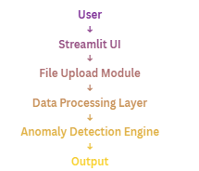
  - Process Flow
- User uploads CSV file or enters claim amount
- Dataset is loaded using pandas
- Mean and standard deviation are calculated
- Z-score is computed
- Threshold logic checks anomaly

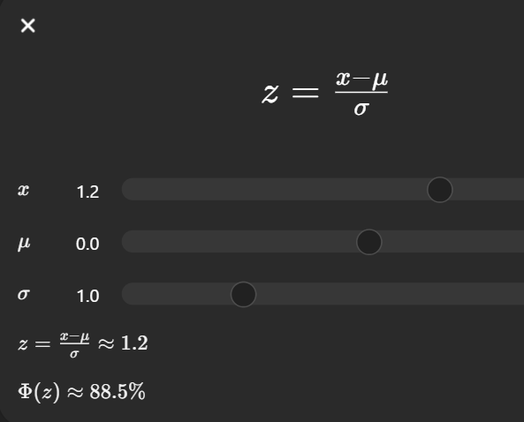
Where x is claim amount, μ is mean, and σ is standard deviation.

2.3Information Flow
The Information Flow explains how data moves through the Healthcare Anomaly Detection System. First, the user uploads a dataset or enters a claim amount through the Streamlit interface. The input data is then sent to the processing module where it is read and validated. After that, the anomaly detection module applies the Z-score method to analyze claim amounts and identify unusual transactions. Finally, the processed results are displayed to the user in a clear tabular format.
User Input → Processing → Z-score Analysis → Output
2.4 Components Design:
The system is divided into different components to improve efficiency and maintainability.
- Input Component – Accepts CSV file upload and manual claim entry
- Processing Component – Reads and prepares dataset using pandas
- Detection Engine – Applies Z-score logic to detect anomalies
- Output Component – Displays results in Streamlit interface
Each component performs a specific function and works together smoothly.

2.5 Key Design Considerations
The following factors were considered during system design:
- Accuracy in anomaly detection
- Fast processing speed
- Easy-to-use interface
- Scalability for future data growth
- Maintainability of code structure

2.6 API Catalogue
No external APIs are used in this project. All operations are performed locally using Python libraries such as pandas, NumPy, and Streamlit..
- Data Design

  - Data Model
The system uses a structured dataset containing healthcare claim details. Important fields include:
- patient_id
- provider_id
- claim_amount
- claim_date
These fields are used to identify suspicious claim transactions

  - Data Access Mecha
The uploaded CSV file is accessed dynamically during runtime using pandas functions.

df = pd.read_csv(uploaded_file)

This allows quick loading and analysis of the dataset.

4. Data Structures
Data | Type
Dataset | DataFrame
claim_amount | Numeric
z-score | Numeric
anomaly | string

5. Function-Level Design
5.1 detect_anomalies(df)
Input: Dataset (DataFrame)
Output: Dataset with Z-score and anomaly column
Main function of the system. It processes the dataset and identifies anomalies using statistical methods.

5.2 calculate_mean_std(df)
Input: Dataset
Output: Mean and Standard Deviation
Calculates statistical measures required for Z-score computation.

5.3 compute_z_score(df, mean, std)
Input: Dataset, mean, standard deviation
Output: Z-score values
Computes how far each claim amount deviates from the mean.

5.4 classify_anomaly(df)
Input: Z-score values
Output: Anomaly label (Yes/No)
Classifies transactions as Normal or Ano

5.5 process_input_data(uploaded_file)
Input: Uploaded CSV file
Output: DataFrame
Reads and converts input dataset into structured format

  - display_results(df)
Input: Processed dataset
Output: Displayed results in UI
Displays anomaly detection results using Streamli
6. Interface Design
6.1 Input:
- CSV dataset upload
- Manual claim amount input
Description:
The system allows users to upload healthcare datasets or manually enter claim amounts for anomaly detection.
Example Input:
patient_id: 102
provider_id: 45
claim_amount: 250000
claim_date: 2024-03-12

6.2 Output Interface
Output:
- Processed dataset
- Z-score values
- Anomaly status
Description:
The system displays results clearly with anomaly labels for each transaction.
Example Output:
patient_id: 102
provider_id: 45
claim_amount: 250000
z_score: 3.2
anomaly: Yes

7. Visualization
Visualization helps in understanding data patterns visually.
Key Points:
- Displays claim amount trends
- Highlights abnormal spikes
- Improves data interpretation
- Supports anomaly detection

8.Error Handling
The system ensures smooth execution by handling errors.
Handled Cases:
- Missing dataset
- Invalid input values
- Empty data
- Incorrect format

9. Performance Considerations
The system is optimized for efficient processing.
Key Points:
- Uses pandas for fast computation
- Handles medium datasets efficiently
- Minimal processing time
- Lightweight application

10. References
The following resources were used in the development of this project:
- Python Official Documentation
- Pandas Library Documentation
- Streamlit Documentation
- NumPy Documentation
- Online tutorials and academic materials on anomaly detection
- Research articles on Z-score based outlier detection

